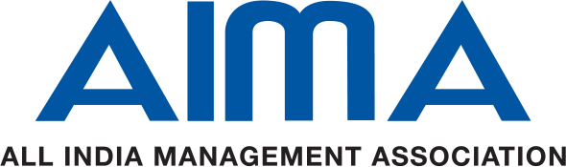

3rd HR Power Workshop  Kolkata  28 Feb & 1 Mar, 2025  BENEFITS OF SPONSORSHIP | Main Sponsor  (5 Lacs) | Co-Sponsors  (4 Lacs ) | Sponsor  (2.5 Lacs) | Associate Sponsor  (1.5 Lacs)
- Opportunity for Head of Organization /Dept to come onboard as a speaker at a mutually agreed session/panel. | ✓
- Sponsors will be allowed screening of their corporate film (2-3 minutes duration) during the breaks. | ✓  5 mins | ✓  3 mins
- Sponsors logo will be featured in all event promotional activities including event webpage, social media campaigns, e-mailers, e-fliers etc. | ✓ | ✓ | ✓ | ✓
- The sponsor’s logo will be displayed prominently on the sides panels of the backdrop in the 2 day HR Power Workshop, Kolkata | ✓ | ✓ | ✓ | ✓
- Logo branding on the holding slide to be displayed before the start of the HR Power Workshop. | ✓ | ✓ | ✓ | ✓
- Logo will be displayed using Panels/Hoardings at the venue. | ✓ | ✓ | ✓ | ✓
- Special announcements thanking sponsors during the HR Power Workshop | ✓ | ✓ | ✓ | ✓
- Complimentary delegates from the sponsor companies to participate at the HR Power Workshop, Kolkata | 8 | 6 | 4 | 2

Note:
- Logo size and positioning will vary depending on the level of sponsorship
- Sponsorship amounts are exclusive of any taxes applicable and sponsoring company needs to bear the cost

For more details, please contact:

Dipen Sharma
Assistant Director-CMD
All India Management Association
Mobile: 9953551926
Email: dsharma@aima.in

