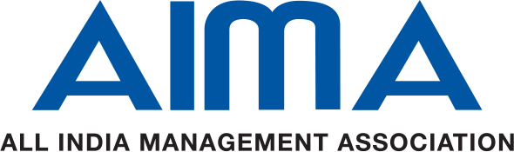

11th AIMA Business Responsibility Summit  AIMA Lajpat Nagar, New Delhi  27 Sep, 2024  BENEFITS OF SPONSORSHIP | Main Sponsor  (10 Lacs) | Co-Sponsors  (5 Lacs ) | Sponsor  (3 Lac) | Associate Sponsor  (2 Lac)
- Opportunity for Head of Organization /Dept to come onboard as a speaker at a mutually agreed session/panel. | ✓
- Sponsors will be allowed screening of their corporate film (2-3 minutes duration) during the breaks in Finale. | ✓  5 mins | ✓  3 mins
- Sponsors logo will be featured in all event promotional activities including event webpage, social media campaigns, e-mailers, e-fliers etc. | ✓ | ✓ | ✓ | ✓
- The sponsor’s logo will be displayed prominently on the sides panels of the backdrop in the Summit. | ✓ | ✓ | ✓ | ✓
- Logo branding on the holding slide to be displayed before the start of the Summit. | ✓ | ✓ | ✓ | ✓
- Logo will be displayed using Panels/Hoardings at the venue. Also, digital panels/Page thanking sponsors to be displayed between sessions, on the event page | ✓ | ✓ | ✓ | ✓
- Special announcements thanking sponsors during the Summit. | ✓ | ✓ | ✓ | ✓
- Complimentary CSR project entries from the sponsor companies to participate at the Summit | 3 | 2 | 1 | 0
- Complimentary delegates from the sponsor companies to participate at the Summit | 8 | 5 | 3 | 2

Note:
- Logo size and positioning will vary depending on the level of sponsorship
- Sponsorship amounts are exclusive of any taxes applicable and sponsoring company needs to bear the cost

For more details, please contact:

Dipen Sharma
Assistant Director-CMD
All India Management Association
Mobile: 9953551926
Email: dsharma@aima.in

