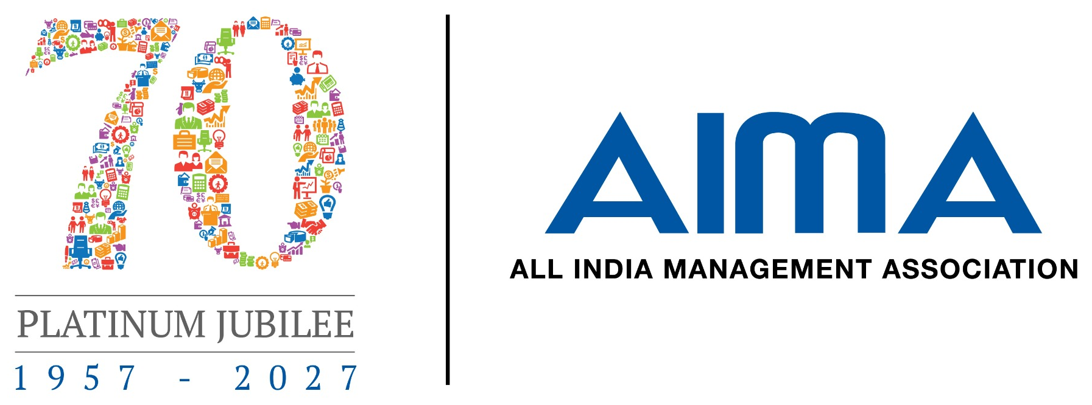
AIMA’s 13th CSR PROJECT
EXCELLENCE CONTEST 2026

A national platform for companies and implementing agencies to showcase credible, measurable and sustainable CSR projects.
CATEGORY I  Corporate CSR Project Excellence  (For Corporates – PSUs & Private Sector) | CATEGORY II  CSR Implementation Excellence  (For Implementation Partner/Agency)
ENTRIES CLOSE:31 Aug 2026
ABOUT THE CONTEST
AIMA’S 13th CSR Project Excellence Case Study Contest creates visible and lasting value
The Contest recognizes both the organisation that funds and governs a CSR project and the implementing agency that converts intent into outcomes on the ground.
OVERVIEW
All India Management Association (AIMA) CSR Project Excellence Contest provides a credible forum to present projects that respond to real community needs, demonstrate disciplined implementation, use evidence for decision-making and show potential for sustainability, replication or scale.
CONTEST OBJECTIVES  ● Recognize high-quality CSR projects with demonstrable outcomes.  ● Encourage companies to strengthen project design, governance and monitoring.  ● Acknowledge the contribution of implementing agencies and field teams.  ● Promote evidence-based impact assessment and responsible reporting.  ● Identify scalable, sustainable and replicable models.  ● Create a repository of good practices for wider learning. | WHO CAN PARTICIPATE?  Category I: Corporate CSR Project Excellence  ● Public Sector Undertakings, government companies and private sector companies undertaking eligible CSR projects.  ● The applicant should have funded, approved, governed, monitored or supervised the project.  ● Joint entries with the implementing partner are encouraged.  Category II: CSR Implementation Excellence  ● Eligible Section 8 companies registered public trusts, registered societies, statutory or government-established entities.  ● The agency should have a formal mandate and substantial responsibility for field implementation.  ● A valid CSR Registration Number should be provided wherever applicable.

ELIGIBILITY AND ASSESSMENT

Qualification Criteria and Evaluation Framework

Category I — Corporates- PSU and Private Sector - CSR Project Excellence
Projects are judged on the quality of evidence and results—not merely on the size of the company, project budget or number of beneficiaries claimed.
Common qualification criteria  ● Each entry must cover one clearly identifiable CSR project—not the organisation’s generic CSR portfolio.  ● The project must align with an eligible CSR purpose and be operational for at least six months.  ● Completed and ongoing projects are both eligible, provided meaningful milestones and results can be demonstrated.  ● The applicant must have been directly and substantially involved in funding, governance or implementation.  ● Claims must be supported by project, monitoring, financial and outcome evidence.  ● Implementing agencies submitting independently must provide consent or a no-objection letter from the funding company. | What will not qualify?  ● Generic corporate CSR profiles or multiple unrelated projects in one entry.  ● Marketing, sponsorship, political contribution or normal-course-of-business activities presented as CSR.  ● A vendor, consultant, auditor or event agency with only a limited service role.  ● Projects exclusively benefiting employees and their families.  ● Entries containing fabricated data, undisclosed duplication or material misrepresentation.

Evaluation Criteria  Category I : Corporates (PSUs & Private Sector) | Weight
Relevance Of Need and Alignment with CSR Priorities | 15%
Complexity Of Problem/Challenge Addressed | 15%
Quality Of Solution | 15%
Monitoring, Outcomes, Sustainability, Scalability and Learning | 25%
Innovation & Transparency of Information | 10%
Quality Of Presentation | 15%
Evaluation Criteria  Category II : Implementing Partner/Agency | Weight
Needs assessment and community participation | 15%
Quality, timeliness and integrity of implementation | 25%
Project team, partnerships, inclusion and safeguarding | 15%
Monitoring, data quality and evaluation | 15%
Sustainability, innovation, scalability and learning | 15%
Quality Of Presentation | 15%
Evidence note: Independent or third-party impact assessment can be submitted where legally applicable or available. Otherwise, credible internal evaluation, beneficiary surveys, government verification or outcome-tracking reports may be provided.

SUBMISSION GUIDE
Tell the Project Story in 13 slides or fewer
The presentation should be concise, evidence-led and easy for the Jury to assess. Supporting documents may be attached separately as annexures.
13  SLIDES MAXIMUM  Including cover and closing slide | 22+  FONT SIZE  Recommended minimum for body text | 1  PROJECT PER ENTRY  With all partners clearly disclosed
SUGGESTED PPT SLIDES STRUCTURE
  1 | Cover and entry category – Project title, applicant, partner, location and duration
  2 | Project snapshot and CSR alignment – Need, CSR priority, target group and key facts
  3 | Baseline and challenge complexity – Evidence, community voice and operating context
  4 | Solution and theory of change – Design, objectives, activities and intended outcomes
  5 | Implementation quality and milestones – Processes, timeline, delivery integrity and adaptation
  6 | Team, partnerships and safeguards – Roles, capability, inclusion, participation and ethics
  7 | Governance, budget and transparency – Approvals, outlay, utilization, disclosures and oversight
  8 | Monitoring, MIS and data quality – Indicators, reviews, verification and corrective action
  9 | Outputs against targets – Reach, activities, achievements and variances
  10 | Outcomes and impact – Evidence of change, evaluation and beneficiary experience
  11 | Sustainability and scalability – Ownership, exit strategy, replication and institutionalisation
  12 | Innovation and learning – New practices, challenges, lessons and transferability
  13 | Case for recognition and declaration – Summary against criteria and partner acknowledgement
Supporting documents (optional)  ● Baseline or needs-assessment report  ● Project agreement / approval  ● Monitoring dashboard or progress reports  ● Utilization certificate / audit evidence  ● Evaluation or impact report  ● Company consent for an agency-led entry  SUBMIT BY 31 August 2026  Registration form + PPT/PDF +  supporting annexures + declaration/consent | Selection process  ● Eligibility screening  ● Documentary evaluation  ● Shortlisted jury presentation  ● Reference or evidence verification  ● Recognition of the best project in each category  For Participation Contact:  Mr Dipen Sharma  Asst Director, CMD, AIMA  Email: dsharma@aima.in |  Mobile: 9953551926

